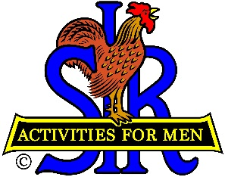
SIR State Bowling Committee
Sir Russ Salazar, Chairman
(530) 644-3809 * RCSALAZAR@AOL.COM

SIR STATE BOWLING COMMITTEE MEETING
10:00 AM Tuesday May 26, 2020

PROPOSED AGENDA

10:00 AM Call to Order/Pledge of Allegiance/Opening remarks Russ Salazar
A. Review/Approval of Agenda
B. Current status of SIR Bowling Activity
10:10 Secretary’s Report – Roll Call/Quorum Gary Kaufmann
A. Review/Approve Minutes of 2/22/20 meeting
10:20 Treasurer’s Report - Review/Approve 4/30 Financial Report Larry Mustain
10:30 Bowling Committee Communication Dan Weller
A. Zoom teleconferencing program
B. Constant Contact messaging program
10:45 Resumption of SIR bowling tournaments/leagues Ray DiBasilio
A. When?
B. Current USBC, State/County, SIR State Board restrictions
B. Anticipated health and safety measures
1. Social distancing – Masks, hugs, high fives, elbow taps
2. Use of adjoining lanes, limit number of bowlers per lane
3. Hand washing/sanitizing, ball sanitizing
4. Carpooling, other
C. Expected participation
11:15 Proposed Rule change Russ Salazar
A. Widows participation in SIR bowling
11:30 New Business Russ Salazar
A. Discussion of proposed SIR bowling poster/flyer
11:45 Closing Remarks Russ Salazar
A. Future of SIR Bowling Activity - Tournaments/Leagues
B. Next meeting – General Committee/TMs meeting -
10:00 AM Saturday August 15, 2020 (Tentative)
12:00 PM Adjourn

