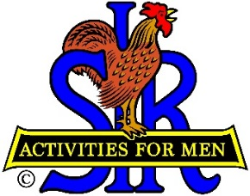
SIR State Bowling Committee
9461 State Hwy. 193. #27, Placerville, CA 95667
Sir Russ Salazar, Chairman
(530) 644-3809 * RCSalazar@aol.com

GENERAL MEETING (ZOOM)
10:00 AM, SATURDAY, AUGUST 15, 2020

AGENDA

OPENING REMARKS – Russ Salazar, Chairman
Flag Salute, Review/Approve Agenda

SECRETARY’S REPORT – Gary Kaufmann, Secretary
Review/Approve Minutes of May 26th Meeting

TREASURER’S REPORT – Sir Larry Mustain, Treasurer
Review/Approve Current Financial Report

REVIEW OF TOURNAMENT REQUIREMENTS – Dan Weller, Vice Chair/Web Mgr.
Schedule Tournament, USBC Sanction, Application, Results, Closing Report.

STATUS OF 2020 TOURNAMENT SEASON – Ray DiBasilio, Operations Advisor
Review Past and Remaining 2020 Schedule

PLANNING FOR 2021 TOURNAMENT SEASON – Ray DiBasilio
Prepare Tentative 2021 Schedule

NEW BUSINESS – Russ Salazar

OLD BUSINESS – Russ Salazar
Committee Vacancies, Widow’s Participation

CLOSING REMARKS – Russ Salazar
Next Meeting – Saturday February 13, 2021 (Zoom?)

ADJOURN

