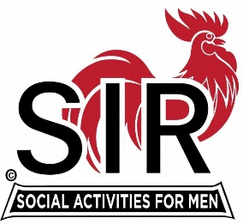

**SIR State Bowling Committee**

**Sir Russ Salazar, Chairman**

**9461 State Highway 193, #27, Placerville, CA 95667**

[**rcsalazar@aol.com**](mailto:rcsalazar@aol.com)

July 22, 2020

Friends:

The world has changed and continues to change. We’re all struggling to adapt to these changes and I truly believe we will all eventually figure out a way to do it and get back to living a full and active life.

Bowling will undergo many changes in the coming months but it will survive and we will all once again enjoy the pleasure and many thrills it will offer. SIR bowling tournaments and leagues came to a screeching halt in April and most bowling centers continue to be dark as of this writing. Most recently the Yuba City and, our favorite, Reno tournaments were cancelled. The Nevada City tournament scheduled in late August and the tournaments scheduled for the rest of 2020 are on a “wait and see” status.

The SIR State Bowling Committee members, SIR Tournament and League managers, and all the other leaders and organizers of SIR bowling activities are invited to participate in a very important meeting via Zoom to be held at **10:00 AM on Saturday August 15, 2020.** We will be discussing two important issues: SIR bowling activities for the remainder of 2020, and, begin the planning process for bowling activities in 2021. Please plan to participate and be prepared to speak about your individual tentative or final plans as they pertain to the two discussion issues.

Sir Dan Weller will send you an invitation to the Zoom meeting a few days before August 15th with the required meeting ID and password for you to join us.

If you have any questions regarding the issues please contact Sir Ray DiBasilio at (530) 558-9727 or [RDiBasilio@GMail.com](mailto:RDiBasilio@GMail.com).

If you need help regarding participation in the Zoom meeting please contact Sir Dan Weller at (925) 935-5510 or [Dweller@Astound.net](mailto:Dweller@Astound.net).

Hope to “See” you all on August 15th.

Sir Russ Salazar, Chairman