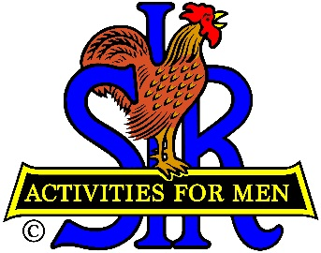
SIR State Bowling Committee
Sir Russ Salazar, Chairman
(530) 644-3809 * RCSALAZAR@AOL.COM

April 30, 2021

Friends:
The SIR State Bowling Committee members, SIR Tournament and League managers, and all the other leaders and organizers of SIR bowling activities are hereby invited to participate in a very important meeting via Zoom to be held at 3:00 PM on Saturday May 8, 2021 instead of May 22nd as previously announced due to a recent SIR mandate that affects all SIR bowling activities.
SIR State President Stu Williams has recently informed all SIR branches and standing committees (including the State Bowling Committee) that, effective May 1st and until further notice, all SIR members and guests must be fully vaccinated in order to participate in SIR activities including SIR meetings and all other partially and fully indoors activities. I’ve attached a copy of President Stu’s notice. The main focus of the May 8th meeting will be to discuss the new mandate and decide what we must do to continue SIR bowling activities.
Please plan to participate in the discussion and, in the meantime, think about possible ways we can deal with the mandate. Also, be prepared to speak about your individual tentative or final plans as they pertain to the 2021 resumption. A proposed agenda is attached for your review and comment. Please send your comments and/or suggestions to me as soon as possible.
Sir Dan Weller will send you an invitation to the Zoom meeting a few days before May 8th with the required meeting ID and password for you to join us. Please RSVP your attendance to Sir Dan asap. If you have any questions regarding the issues to be discussed, please contact Sir Ray DiBasilio at (530) 558-9727 or email Ray at RDiBasilio@GMail.com. If you need help regarding participation in the Zoom meeting please contact Sir Dan Weller at (925) 935-5510 or email Dan at DWeller@Astound.net.
Hope to “See” you all on May 8th.
Sir Russ Salazar, Chairman
SIR State Bowling Committee

