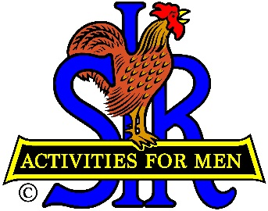
SIR State Bowling Committee
Sir Russ Salazar, Chairman
(530) 644-3809 * RCSALAZAR@AOL.COM

October 6, 2021

Friends:
The SIR State Executive Bowling Committee members, SIR Tournament and League managers, and all the other leaders and organizers of SIR bowling activities are hereby invited to participate in a very important meeting via Zoom to be held at 2:00 PM on Friday October 22, 2021.
Highlights of the meeting will include the introduction of the 2022 SIR Executive Committee Members, the proposed 2022 SIR Bowling Tournament Schedule, SIR Widows bowling tournament eligibility, SIR tournament USBC Composite/SBTA averages, and ways to promote participation in future SIR Annual Bowling Tournaments,
All tournament managers should have planned their 2022 SIR tournament dates and coordinated finalization with their bowling center and Sir Ray DiBasilio, Operations Advisor for the Executive Bowling Committee. We will present our proposed 2022 tournament schedule to the SIR State Board for final approval at their November meeting.
A proposed agenda is attached for your review and comment. Please send your comments and/or suggestions directly to me as soon as possible.
Sir Dan Weller will send you an invitation to the Zoom meeting a few days before October 22nd with the required meeting ID and password for you to join us. Please RSVP your attendance to Sir Dan ASAP. If you have any questions regarding the issues to be discussed, please contact me directly at (530) 644-3809 or RCSALAZAR@AOL.COM.. If you need help regarding participation in the Zoom meeting please contact Sir Dan Weller at (925) 935-5510 or email Dan at DWeller@Astound.net.
Hope to “See” you all on October 22nd.
Sir Russ Salazar, Chairman
SIR State Bowling Committee

