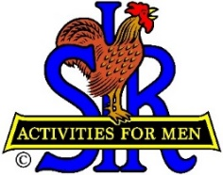
SIR State Bowling Committee
Sir Dan Weller, Chairman
925-935-5510 dweller@astound.net

SIR STATE BOWLING COMMITTEE
GENERAL MEETING (ZOOM)
10:00 AM Saturday, September 10, 2022
AGENDA

10:00 - OPENING REMARKS - Sir Dan Weller, Chairman
Welcome, Flag Salute, Review/Approve Agenda

10:10 - SECRETARY’S REPORT – Sir Dan Weller, Chairman sub for Gary
Discuss Key Items of the June 6th Meeting

10:20 - TREASURER’S REPORT – Sir Larry Mustain, Treasurer
Review/Approve Current Financial Report

10:30 - Status of updating the Bowling By-Laws and Rules – SIR John Manahan, Policy Advisor

10:45 – Status of the 2023 Bowling Calendar – Sir Ray DiBasilio. Operations Advisor

11:10 - Comments on the 2022 SIR State Bowling Tournament – SIR Dan Weller, Chairman

11:25 - Questions and comments from the Tournament Managers and Bowling Activity Chairmen

11:35 - NEW BUSINESS – Sir Dan Weller

11:40- OLD BUSINESS – Sir Dan Weller

11:55 - CLOSING REMARKS – Sir Dan Weller
Next meeting (General Committee) – 10:00 AM Saturday November 12, 2022

12:00 - ADJOURN

