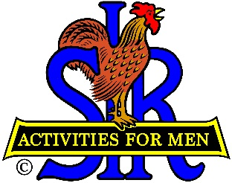
Sons In Retirement (SIR)
State Bowling Committee
11583 Prospect Hill Drive
Gold River, CA 95670
(916) 635-5674

2021 ANNUAL FINANCIAL REPORT
January 1, 2021Through December 31, 2021
Income
Beginning Balance (January 1, 2021 $ 6,032.74
Add receipts (Ten-pin Assessment) $ 62.40
Checking Interest $1.15
$ 6,096.29

Less Expenses:

Other Expenses $ 1,289.50

Net Income/Loss $ 4,806.79

Ending Balance (December 31, 2021) $ 4,806.79

Notes:

Respectfully Submitted

Sir Larry Mustain, Treasurer
SIR State Bowling Committee

