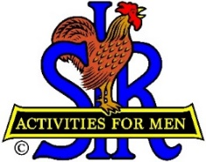
SIR State Bowling Committee
Sir Dan Weller, Chairman
925-935-5510 dweller@astound.net

,
SIR Bowling Committee Meeting
When: Saturday September 9, 10 AM – Noon
How: Zoom Meeting
Credentials:
Link: Click Here
Meeting ID: 925 935 5510
Passcode: 279941
Please send me suggestions for meeting topics. The agenda will be published a week before the meeting.

